Vlad Predovic

Due April 3rd 3016

CS 352

Unit 2.2 Exercise

## P: begin by writing down what you know and especially what you don’t know. Focus on things that affect usability, not on “software functions”. For example, think about your target user population, what their use of an online grocery might be, what problems those people have that you’d like to solve, and so on.

What I know:

1. Selling groceries, groceries expire unlike merchandise, included in UI.
2. People like multiple options of the same grocery to choose from with varying prices and health benefits (Scroll through options of same item?)
3. Local trends (EX: “organic”) (how to show trendy items?)

What I don’t know:

1. What the customer demographic will be (different demographics want different items)
2. Customer ease with technology (how simple to make website)
3. Distribution system from online to customer’s house
4. Payment system, what to allow, how to save credit cards securely.

## C: Using what you’ve done above, sketch at least 3 concepts for your online grocery. Try to make them very different from each other.

1. 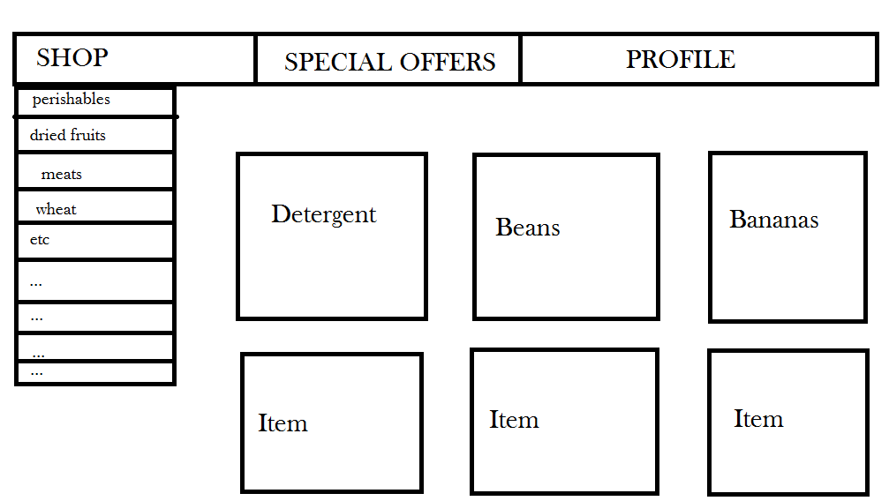Complex but robust grocery store. Allows for viewing based on many different categories and allows the user to create profile. Items appear on the middle to lower right hand side of the screen. This version might be a little complex for some users but allows for many different options.

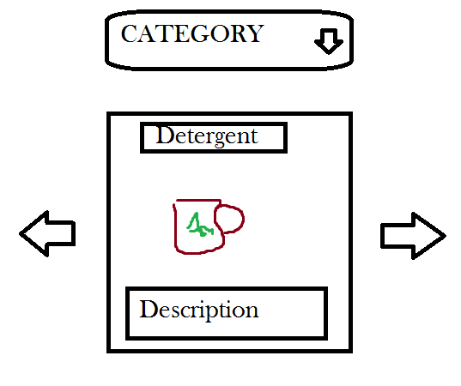

1. Simple and quick grocery store used for emergency situations or for very non-tech savvy users who need to buy essentials. Quickly select a category and then you can swipe through a series of options. Very mobile friendly for if buying on the run or need to brainstorm common household goods.
2. The most minimalist option of the three, Your Personal Helper requires some degree of tech savviness for querying as the only way to look for options is using a search bar. However it also allows you to save a list of items in a similar fashion to a grocery list.

